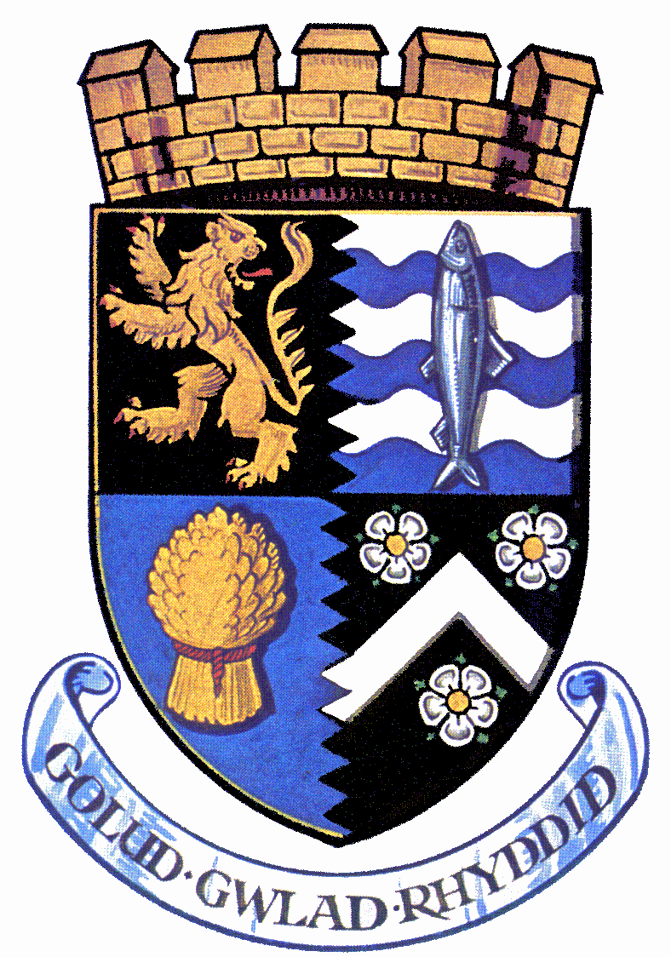**CYNGOR SIR CEREDIGION**

**CEREDIGION COUNTY COUNCIL**

**THIS IS TO CERTIFY that:**

**Has been exempted from the Licensing of Children on the following dates:**

By virtue of a Body of Persons issued by: **Ceredigion County Council** *in accordance with S.37(3) {b} of the Children & Young Persons Act 1963 and The Children (Performances and Activities)Wales) Regulations 2015*

**This exemption applies only to rehearsals and performances for ‘ ’** that take place at **‘ ’**

The above named body have entered into a written ‘Contract of Agreement’. Please ensure this exemption is present during the performance as it may be required for inspection by any Police Officer or Authorised Officer of the Local Authority

Signed …………………… Date ………………………..

Meinir Ebbsworth

Corporate Lead Officer – Schools