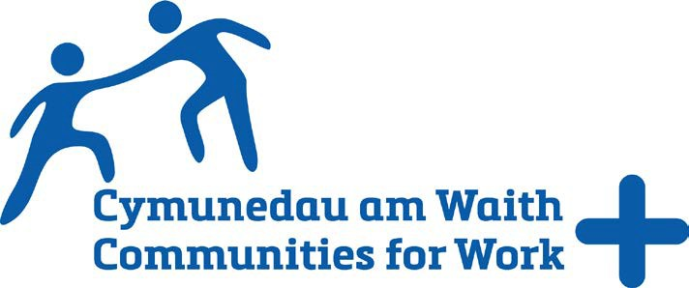 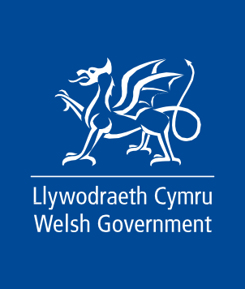

# Annex 1

Participant Enrolment Form

# Privacy Notice: PN00001131 Communities for Work+ (CfW+) Section 1: Please read the following statement

Communities for Work+ (CfW+) is an employability programme funded by the Welsh Government. Local authorities and third sector organisations, deliver the services of the CfW+ programme on behalf of the Welsh Government who will be the data controller for the personal information you provide on this enrolment form. We will process it in pursuance of our public task and the official authority vested in us so as to enable us to contribute to the commitments made by the Welsh Government in ‘Stronger, fairer, greener Wales: a plan for employability and skills’. Without this information your enrolment cannot be accepted.

What will the Welsh Government use your information for?

The Welsh Government will use your data for:

* Funding purposes, planning and policy development as well as monitoring programme outcomes (such as entering employment, achievement of qualifications).
* Administration, verification, and audit purposes.
* Generating statistics about the CfW+ programme. Any statistics published by the Welsh Government are anonymised, meaning that you as an individual cannot be identified.
* Sharing good news stories to help promote and publicise the services of CfW+ to encourage more enrolments to the programme. Unless you give specific consent, your information will remain anonymous so that your identity is protected.

The Welsh Government shares your data with:

* An evaluation company who are contracted to undertake an evaluation of the CfW+ programme on behalf of Welsh Ministers, which includes how CfW+ services may have helped you improve your employment prospects or helped you into work. Your data will be shared with the evaluators, and they may contact you to ask how CfW+ has helped you prepare for work or helped you into work.

How will Welsh Government keep my data safe?

The data the Welsh Government collects about you will be stored in an access controlled secure database which is regularly tested for safety and integrity. The Welsh Government will have a formal data sharing agreement in place whenever we share your data with a third party.

What are my rights and choices?

Under the General Data Protection Regulation (GDPR) you have the right to:

* access the personal data the Welsh Government holds on you;
* require the Welsh Government to rectify inaccuracies in that data;
* object to processing on grounds relating to your particular situation (in some circumstances);
* restrict processing (in some circumstances);
* have your data erased (in certain circumstances);
* lodge a complaint with the Information Commissioner’s office (ICO) who is the independent regulator for data protection.

How long will the Welsh Government keep my information?

Welsh Government and the Local Authorities and Third Sector Organisations who are programme deliverers are required to keep your information for a maximum of 7 years after the end of the financial year to which it relates, unless informed differently by Welsh Ministers. Your information will then be securely destroyed after it is no longer required for these purposes.

Contacts

For further information about the information which Welsh Government holds and its use, or if you wish to exercise your rights under the GDPR, please see contact details below:

Communities for Work Plus Welsh Government Cathays Park

Cardiff CF10 3NQ [communitiesforworkplus@gov.wales](mailto:communitiesforworkplus@gov.wales)

Data Protection Officer Welsh Government Cathays Park

Cardiff CF10 3NQ [dataprotectionofficer@gov.wales](mailto:dataprotectionofficer@gov.wales)

To contact the Information Commissioner’s Office, please see details below: Wycliffe House

Water Lane Wilmslow Cheshire SK9 5AF

Wales Helpline: 01625 545745 or UK Helpline: 0303 123 1113 [www.](http://www/)[ico.org.uk](https://ico.org.uk/)