A.7. Identity Card

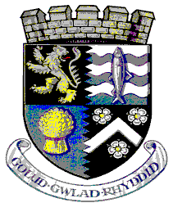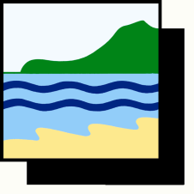

**CYNGOR SIR CEREDIGION COUNTY COUNCIL**

***Adran Arfordir a Chefn Gwlad***

**Coast and Countryside Section**

**Neuadd Cyngor Ceredigion, Penmorfa, Aberaeron,**

**Ceredigion SA46 0PA**

**Ceredigion County Council’s [INSERT PROJECT NAME] Information Card**

I am a volunteer working on behalf of Ceredigion County Council. I am part of the Council’s [INSERT PROJECT NAME]. I am authorised to undertake works identified in the Memorandum of Understanding, surveying and taking photographs as necessary. If you would like further information, please contact [INSERT STAFF MEMBER AS APPROPRIATE].