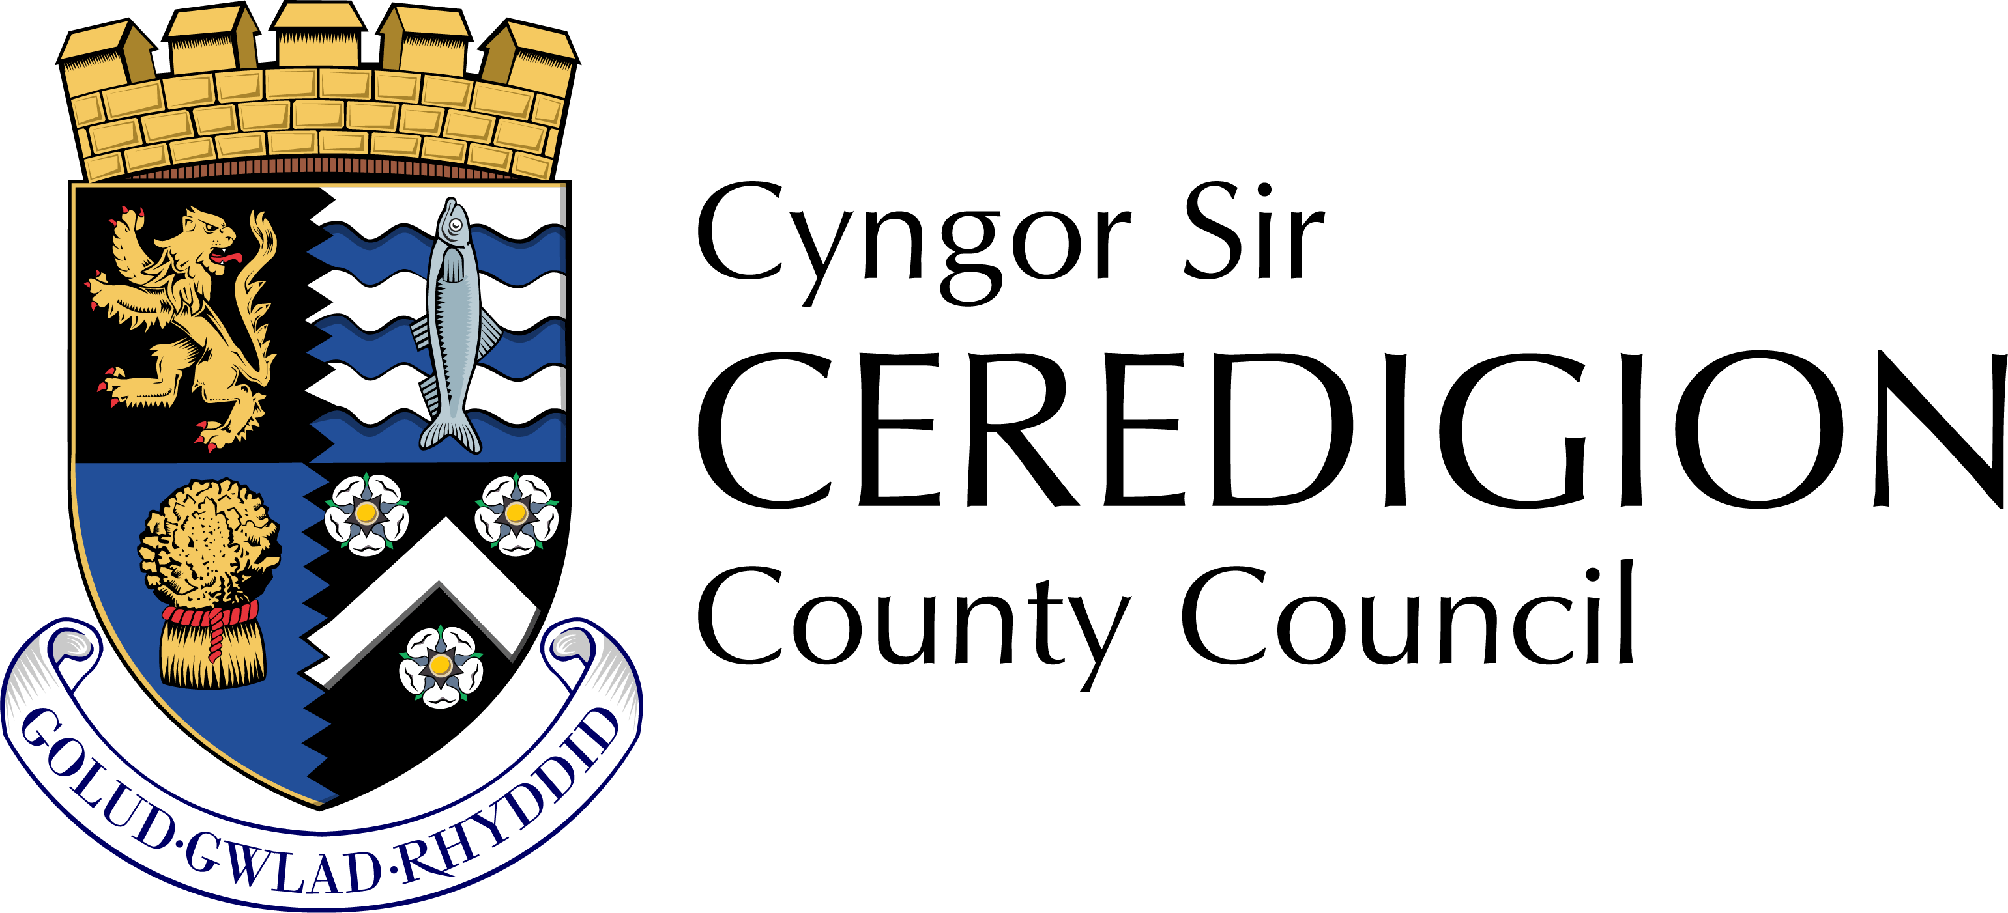

**Ceredigion County Council**

**Personal Assistant Portal Terms and Conditions**

Table of Contents Introduction ....

1. Personal Assistant Register Terms and Conditions

General

Using the Personal Assistant Register

2. Personal Assistants (PA) tasks and responsibilities

Employer’s task and responsibilities

Ceredigion Council (CCC) tasks and responsibilities

3. Suspension or Termination of Accounts.

PA Register Privacy Notices

Personal Assistants

Employers

4. Vacancies Terms and Conditions

Using Vacancies

Employers tasks and responsibilities.

Personal Assistants task and responsibilities

5. Ceredigion County Council (CCC) tasks and responsibilities

6. Suspension or Termination.

Vacancies Privacy Notices

Personal Assistants

Employers

7. Personal data

Introduction

Ceredigion County Council’s Personal Assistant Portal contains.

Personal Assistant Register – a platform for PAs currently available and looking for work to add their profile and for potential employers to view, shortlist and contact PAs who may be suitable for the role they are recruiting for

Vacancies – a platform for employers to advertise their vacancies and for PAs to apply for these roles Ceredigion County Council’s Personal Assistant Register and Vacancies Portal is only available for use by Ceredigion Direct Payment Employers and PAs able to work in Ceredigion. Ceredigion County Council hold no liability or responsibility for the PA’s suitability, quality of work or timeliness. Any agreement or contract is between the Employer and PA and Ceredigion County Council accept no liability or responsibility from any issues that may arise. Any users who have any concerns relating to a PA or Employer can report these concerns to the Direct Payment Support Team, their Social Worker or through the Council’s Compliments, Concerns and Complaints Team By using Ceredigion County Council’s Personal Assistant (PA) portal, you are agreeing to the terms and conditions. These may change occasionally, and the current version can be found on the website.

1. Personal Assistant Register Terms and Conditions General

In order to create a profile or use the PA register you must be;

• at least 18 years old

• a resident in the UK and

• have the right to work in the UK

You may not create more than one account We advise you to regularly update your profile with any additional information or changes in your availability. You should notify the Direct Payment Support Team if you are no longer seeking employment.

If a profile has not been updated or amended for 1 month you will be emailed to check if your availability is up to date. If there is no response and no changes or updates are made within 2 weeks, your profile will be made inactive (unavailable to the public). Once a profile has been inactive for a period of 6 months, it will be deleted.

1. Personal Assistant Register Personal Assistants (PA) tasks and responsibilities

When a PA profile has been created and approved by the Council, the PA will be issued with an account. The PA must: • Ensure the information provided in the profile is accurate, true and not misleading • Ensure the information provided in sections which are available to the public, does not contain any personal contact details or URL links. For further information on these sections please see the example profile. • Ensure the information provided does not include any content, information or images that may be inappropriate or offensive • Ensure the information provided does not breach any laws, third party rights or terms and conditions. • Ensure the information provided does not discriminate any other users • Regularly update their information and availability to work via their secure login • Notify the Council if they are no longer seeking employment and request for their details to be either made unavailable, or deleted from the register entirely • Not share their individual login details with anyone and keep the details secure and confidential • Not share details of any potential Employers with other parties • Notify the Council immediately if there has been a security breach or if they suspect there may have been. • Consent to the Council managing their personal details in accordance to the Data Protection Act • Consent to the Council retaining their contact details for future communications in association with the PA Workforce Communications and updates – they have the right to request contact details to be deleted by contacting tu_dp @ceredigion.gov.uk.

Employers task and responsibilities

Once an Employer has selected the PA’s they wish to shortlist, they will request more information from Ceredigion County Council.

The Employer must; • Not share PA’s details with other parties • Liaise with the Direct Payment Support Team to ensure all Employer liabilities are met during the recruitment process

Ensure the communication does not include any content, information or images that may be inappropriate or offensive • Ensure the communication does not breach any laws, third party rights or terms and conditions. • Ensure the communication does not discriminate any other users.

Ceredigion County Council (CCC) tasks and responsibilities

• Maintain the registry system • Manage the personal details contained with the register and related records in accordance with the Data Protection Act • Approve PA profiles and monitor for any inappropriate content • Suspension and / or termination of profiles where applicable

1. Suspension or Termination of Accounts All profiles and accounts are subject to Ceredigion County Council’s approval. Ceredigion County Council reserve the right to suspend or terminate any profiles at any time where the user has or may have; • Breached any of these terms and conditions • Engaged in any fraudulent activity • Breached any laws or regulations • Acted in a manner which we deem inappropriate.

You can terminate your account at any time by contacting Ceredigion County Council, Direct Payment Support Team 01545 570881 or [tu_dp@ceredigion.gov.uk](mailto:tu_dp@ceredigion.gov.uk)

PA Register Privacy Notices

Personal Assistants -Your data will be processed by Ceredigion County Council only for the specific purpose of providing a platform for assistance with recruitment. The processing of your personal data is necessary for the purposes of recruitment by Direct Payment Employers via the Personal Assistant Portal. Direct Payments are provided as part of Ceredigion County Council’s public task as set out in the Social Services & Well-Being (Wales) Act 2014. Ceredigion County Council will share your information with potential Employers. Ceredigion County Council will retain your information for the duration of you actively seeking employment and for up to 6 months of being inactive.

If you feel that Ceredigion County Council has mishandled your personal data at any time you can make a complaint to the Information Commissioner's Office by visiting their website or by calling their helpline For further information about how Ceredigion County Council processes personal data and your rights please see our privacy notice on our website - <http://www.Ceredigion.gov.uk>.

Employers -Your data will be processed by Ceredigion County Council only for the specific purpose of providing a platform for assistance with recruitment. The processing of your personal data is necessary for the purposes of assistance with recruitment. Direct Payments are provided as part of Ceredigion County Council’s public task as set out in the Social Services & Well-Being (Wales) Act 2014. Ceredigion County Council will not share your information third parties. Ceredigion County Council will retain your information to respond to your request for further information. Once your enquiry has been dealt with satisfactorily, your data will be deleted. If you feel that Ceredigion County Council has mishandled your personal data at any time you can make a complaint to the Information Commissioner's Office by visiting their website or by calling their helpline For further information about how Ceredigion County Council processes personal data and your rights please see our privacy notice on our website - <http://www.Ceredigion.gov.uk>.

4.Vacancies Terms and Conditions

Using Vacancies

Employers tasks and responsibilities When submitting a vacancy / job advert and using the portal the employer must; • Ensure the information provided in the advert is accurate, true and not misleading • Ensure the information provided in sections which are available to the public, does not contain any personal contact details or URL links • Ensure the information provided and any subsequent communication does not include any content, information or images that may be inappropriate or offensive.

Ensure the information provided and any subsequent communication does not breach any laws, third party rights or terms and conditions. • Ensure the information provided and any subsequent communication does not discriminate any other users • Notify the Council if they are no longer looking to recruit and request for their advert to be removed from the public database • Not share details of any potential employees with other parties • Notify the Council immediately if there has been a security breach or if they suspect there may have been. • Liaise with the Direct Payment Support Team to ensure all Employer liabilities are met during the recruitment process • Consent to the Council managing their personal details in accordance to the Data Protection Act • Consent to the Council retaining their contact details for future communications in association Direct Payments – they have the right to request contact details to be deleted by contacting [tu_dp@ceredigion.gov.uk](mailto:tu_dp@ceredigion.gov.uk)

Personal Assistants task and responsibilities If a person chooses to apply for one of the vacancies advertised, they must • Ensure the information provided in their application form or CV is accurate, true and not misleading • Ensure the information provided and any subsequent communication does not include any content, information or images that may be inappropriate or offensive • Ensure the information provided and any subsequent communication does not breach any laws, third party rights or terms and conditions. • Ensure the information provided and any subsequent communication does not discriminate any other users • Notify the Council if they are no longer seeking employment and request for their application to be withdrawn • Not share details of any potential employers with other parties • Notify the Council immediately if there has been a security breach or if they suspect there may have been. • Consent to the Council managing their personal details in accordance to the Data Protection Act • Consent to the Council retaining their contact details for future communications in association with the PA Workforce Communications and updates – they have the right to request contact details to be deleted by contacting tu_[dp@Ceredigion.gov.uk](mailto:dp@Ceredigion.gov.uk)

5. Ceredigion County Council (CCC) tasks and responsibilities • Maintain the database • Manage the personal details contained within the database and related records in accordance with the Data Protection Act • Approve vacancies / job adverts and monitor for any inappropriate content • Manage and collate the applications submitted and pass to the employer for shortlisting • Suspension and / or termination of users where applicable Suspension or Termination All adverts are subject to Ceredigion County Council’s approval. Ceredigion County Council reserve the right to suspend or terminate any adverts at any time where the user has or may have; • Breached any of these terms and conditions • Engaged in any fraudulent activity • Breached any laws or regulations • Acted in a manner which we deem inappropriate You can terminate your account at any time by contacting Ceredigion County Council, Direct Payment Support Team 01545 tu_dp@ceredigion.gov.uk

6.Vacancies Privacy Notices

Personal Assistants

Your data will be processed by Ceredigion County Council only for the specific purpose of providing a platform for assistance with recruitment. The processing of your personal data is necessary for the purposes of recruitment by Direct Payment Employers via the Personal Assistant Portal. Direct Payments are provided as part of Ceredigion County Council’s public task as set out in the Social Services & Well-Being (Wales) Act 2014.Ceredigion County Council will share your information with the potential Employer whose vacancy you have applied for.

7.Ceredigion County Council will retain your information until the vacancy has been closed and recruitment support has ended, at this time your data will be deleted. If you feel that Ceredigion County Council has mishandled your personal data at any time you can make a complaint to the Information Commissioner's Office by visiting their website or by calling their helpline on 0303 123 1113.

8 For further information about how Ceredigion County Council processes personal data and your rights please see our privacy notice on our website - <http://www.ceredigion.gov.uk>

