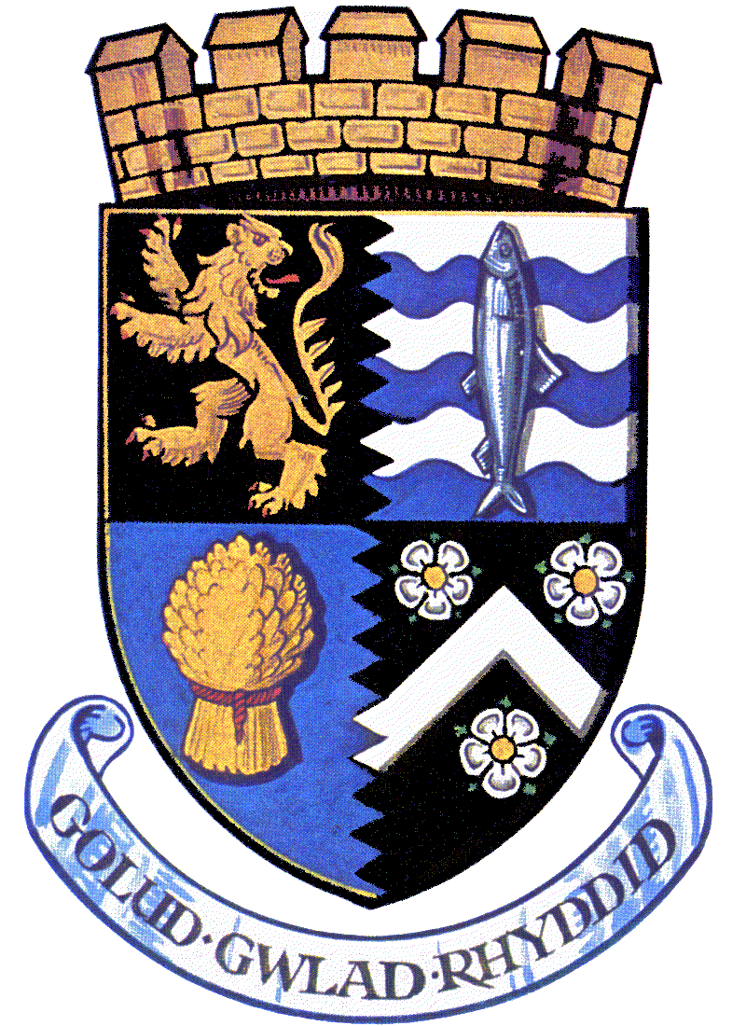

Training Centres for Food Hygiene / Health and Safety Courses
Canolfannau Hyfforddiant ar gyfer cyrsiau Hylendid Bwyd / Iechyd a Diogelwch

TRAINING CENTRE  CANOLFAN HYFFORDDIANT | CONTACT DETAILS  MANYLION CYSYLLTU
Coleg Ceredigion  Llanbadarn Campus  Llanbadarn  Aberystwyth  Ceredigion | : 01970 639700  www.ceredigion.ac.uk  Email / E-bost enquiries@ceredigion.ac.uk  Contact / Cyswllt : Keith Henson
Coleg Ceredigion  Park Place  Cardigan  Ceredigion | : 01239 612032  www.ceredigion.ac.uk  Email / E-bost enquiries@ceredigion.ac.uk  Contact / Cyswllt : Bill Mousley
Food Centre Wales  Horeb  Llandysul  Ceredigion | : 01559 362230  www.foodcentrewales.org.uk  Contact / Cyswllt : Irene Moyle
Paul Wilson  Training Consultant for the Catering and  Food Industries  Y Felin  Abergorlech  SA32 7SN | : 01558 685764  Email / E-bost wilsonp29@hotmail.com  Contact / Cyswllt : Paul Wilson
Sara Rhys-Owens  Sara Safety Solutions  10 Belle Vue Terrace  Pembroke Dock  SA72 6NL | : 07599 123937  www.sarasafetysolutions.co.uk  Email / E-bost rhysowens@btinternet.com  Contact / Cyswllt : Sarah Rhys-Owens

